

FUFO_FUFO
Software Architecture

Project Code: FUFO_FUFO
Document Code: FUFO_FUFO_DD – v1.0.0

Ha Noi, March 10th, 2012

Record of change

*A - Added M - Modified D - Deleted
Effective Date | Changed Items | A*  M, D | Change Description | New Version

SIGNATURE PAGE

ORIGINATOR: Hunghd March 10th, 2012
Developer

REVIEWERS: <Name> <Date>
<Position>

<Name, if it’s needed> <Date>
<Position>

APPROVAL: <Name> <Date>
<Position>
TABLE OF CONTENTS
1 Introduction 5
1.1 Purpose 5
1.2 Scope 5
1.3 Definitions, Acronyms and Abbreviations 5
1.4 References 5
1.5 Overview 6
2 Logical View 7
3 Implementation View 8
3.1 Start State 8
3.2 Waiting for Connection 9
3.3 Verify 9
3.4 Pending 10
3.5 Setup 10
3.6 Ready 11
3.7 Hovering 12
3.8 Landing 12
3.9 Error 12

Introduction

Purpose
This document helps developers understand more clearly about FUFO system. It is also used by customer to review all functions more evidently to prevent misunderstanding of developers about system. Moreover, it is used for integration test, all functions have to map with this document.

Scope
This document describes architectural design guidelines and requirements for the firmware of FUFO. This includes logical view and implement view of the firmware.

Definitions, Acronyms and Abbreviations
Abbreviations | Description | Comment
FUFO | FPT University Flying Object
PWM | Pulse-width modulation
I2C | Inter-integrated circuit
UART | Universal asynchronous receiver/transmitter
TMR | Timer
Accel | Accelerometer
Gyros | Gyroscope
Baro | Barometer

References
N/A

Overview
The content of this SRS is organized as follow:
• Section 1 is a general introduction to this document.
• Section 2 is logical view.
- Section 3 is implementation view.

Logical View
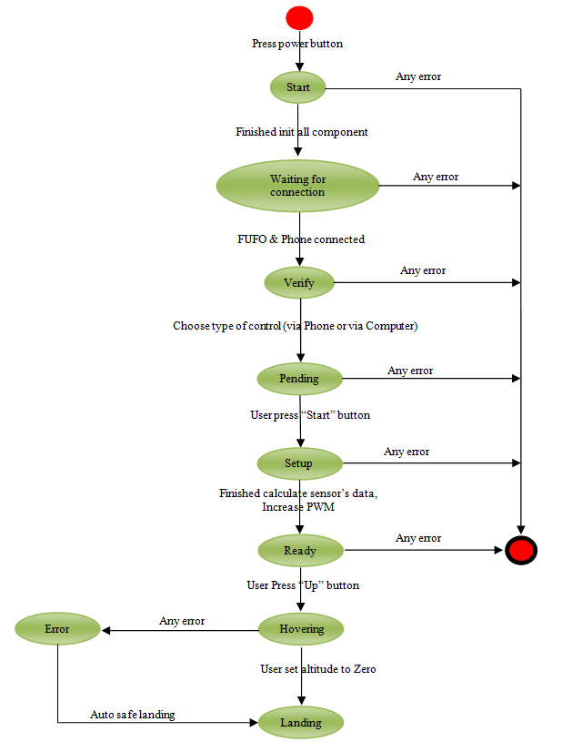
Figure 1 – FUFO State diagram

FUFO State diagram describes overall states of FUFO’s firmware. In Implementation view section, states will describe specifically.

Implementation View

Start State
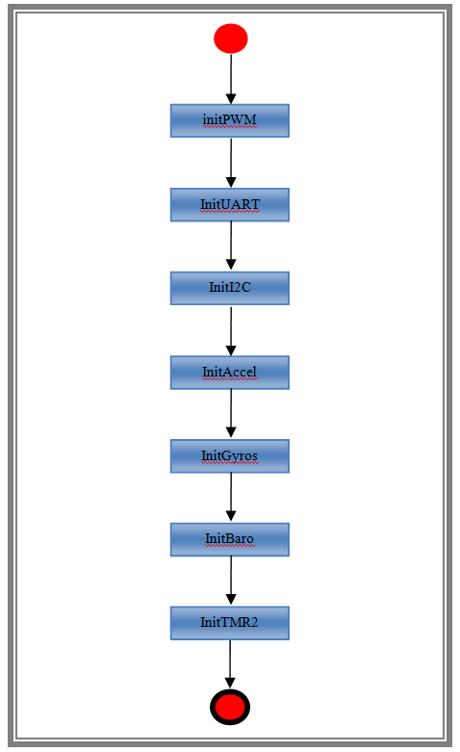
Figure 2 – Start state
If power turned on, FUFO would be in Start state. In this state, FUFO’s firmware initialize communication methods as I2C, UART, and modules as PWM, Accel, Gyros, Baro, TMR2.

Waiting for Connection State
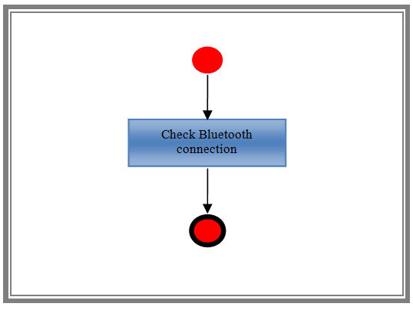
Figure 3 – Waiting for Connection
If FUFO’s firmware initialized successfully communication methods as I2C, UART, and modules as PWM, Accel, Gyros, Baro, TMR2, FUFO would be in Waiting for Connection state. In this state, FUFO’s firmware checks Bluetooth connection between FUFO and Phone.

Verify State
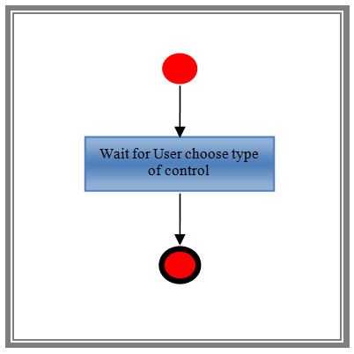
Figure 4 – Verify
If FUFO and Phone connected together, FUFO would be in Verify state. In this state, FUFO’s firmware will check types of control via Phone or Computer.

Pending State
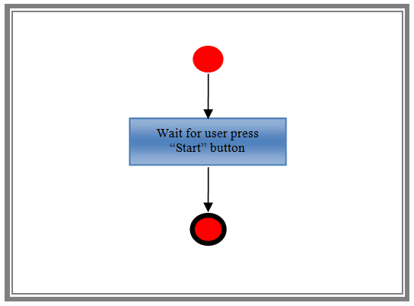
Figure 5 – Pending
If one of control types were chosen, FUFO would be in Pending state. In this state, FUFO’s firmware waits until user press Start button.

Setup State
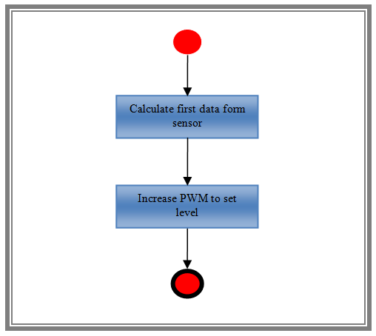
Figure 6 – Setup
If user pressed Start button successfully, FUFO would be in Setup state. In this state, FUFO’s firmware increases PWM to provide thrust level at 40 percent of thrust rate for Brushless motor, and also calculates data which got from gyros to reduce noises.

Ready State
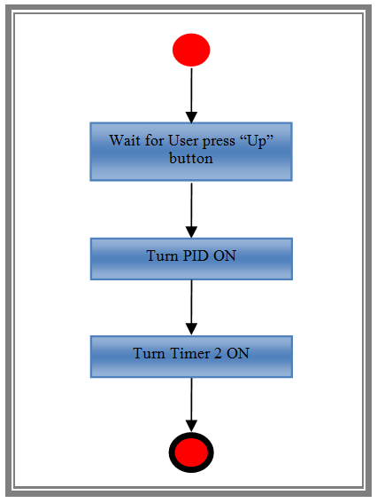
Figure 7 – Ready
If FUFO’s firmware increased PWM and calculated data get from gyros successfully, FUFO would be in Ready state. In this state, FUFO’s firmware will wait for user press “Up” button to set altitude level to 0.5 meters, and then turn TMR2 and PID on.

Hovering State
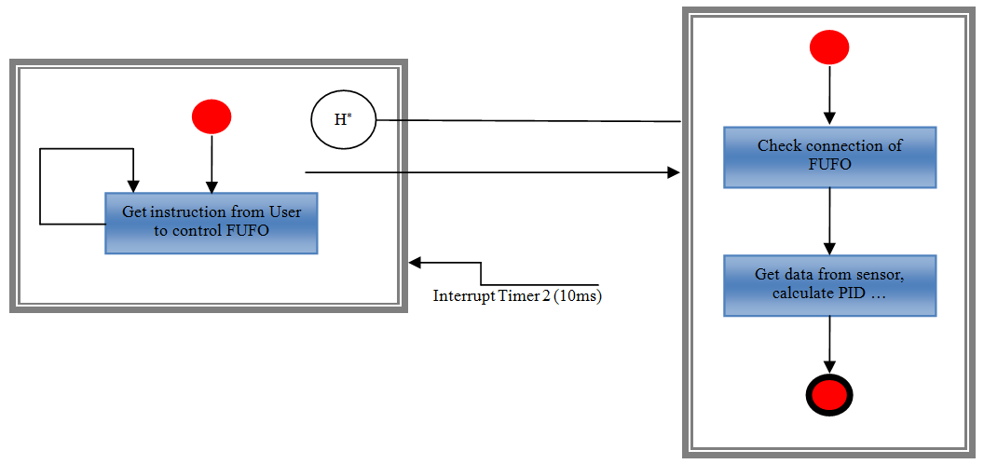
Figure 8 – Hovering
If Setup state completed successfully, FUFO would be in Hovering state. In this state, FUFO’s firmware gets instructions of user (Up, Down, Left, Right, Backward, Forward), when interrupt Timer 2 10ms occurs, FUFO calculates data which got from sensors to control FUFO based on instructions of user.

Landing State
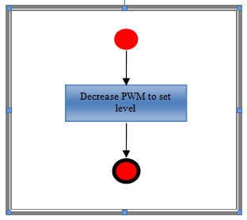
Figure 9 – Landing
If user set altitude level to 0 meter, FUFO would be in Landing State. In this state, FUFO’s firmware will decrease PWM to provide thrust level at 20 percent of thrust rate for Brushless motor, and FUFO will move to Pending state to ready for next fly.

Error State

